AQA English Literature
How to Revise for Paper 2:
Modern Texts and Poetry

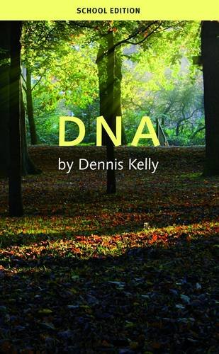
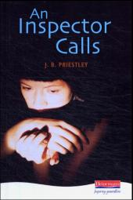

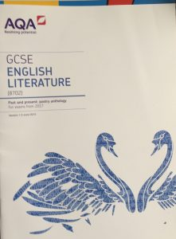

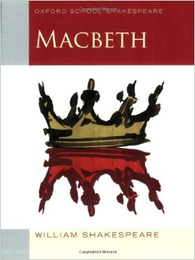
What does the exam involve?

Paper 2 is 2 hours and 15 minutes long and is marked out of 96. There are 4 SPaG marks available for Section A only.
Section A is on Modern Drama: either An Inspector Calls or DNA.
For each play there will be two questions and you only need to answer one. Find the play that you have studied, read both questions and choose which one you have the most ideas for.
SPAG is marked for your Modern Drama answer – so spend 5 minutes checking and correcting any mistakes you might have made when writing against the clock!
Section B is on the poetry anthology. You have studied the Power and Conflict selection of poems so find this section.
- There will be one question which you have to answer.
- One poem from the anthology will be named and there will be a printed copy of this poem.
- You then need to choose a second poem to compare it with.
- There will be a list of the titles of the poems that you have studied, but the actual poems won’t be printed in full.
Section C is on unseen poetry.
- There will be two questions which you have to answer.
- The first is worth 24 marks, and the second is worth 8 marks so divide your time sensibly.
- The first question will give you a poem and a question to answer.
- The second question will give you a second poem and ask you to compare it with the first unseen poem.

How do I revise the drama text?

- Ensure you know the play well, including plot, themes and characters. To do this you could:
- use www.sparknotes.com;
- use BBC Bitesize;
- refer to your revision guides (you can buy these from the library);
- look back through your exercise books from lessons;
- use the revision guides on the Westlands English website.

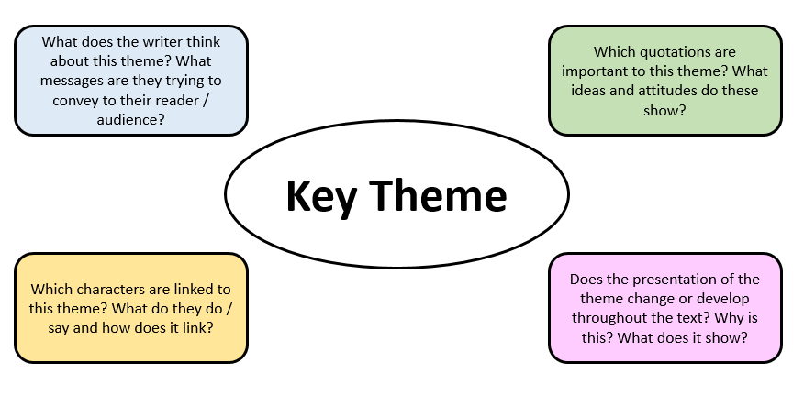
- The question will ask you to focus on either a theme or on a character from the text. Create revision notes (cue cards, mind maps, profiles) of as many themes and characters as you can. Use the questions on the mind maps below as a starting point.
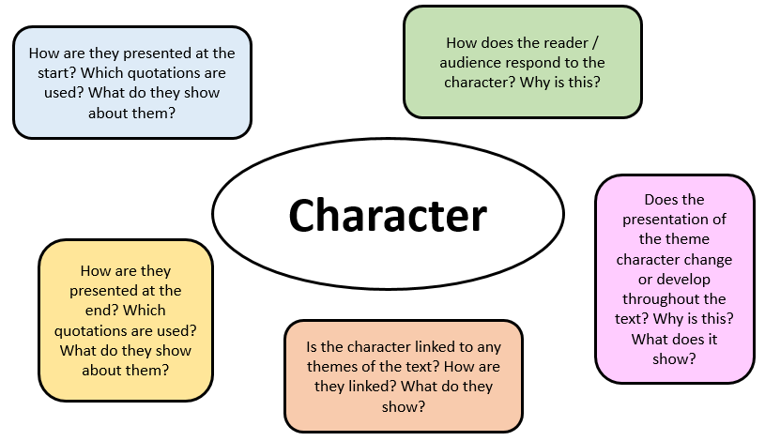

An Inspector Calls Themes | DNA Themes
Responsibility | Gangs
Gender | Leadership
Social class | Responsibility
Blame | Bullying
Morality | Peer pressure
Public vs private spheres | Morality
Wealth | Guilt
Age / generational differences | Group mentality / behaviour
An Inspector Calls Characters | DNA Characters
The Inspector | Phil
Eva Smith / Daisy Renton | John Tate
Mr Birling | Mark and Jan
Mrs Birling | Leah
Eric Birling | Danny
Sheila Birling | Lou
Gerald Croft | Cathy
 | Brian
 | Adam
 | Richard

- Practice planning and then answering questions on your set texts. There are example questions for each text at the end of this booklet. You should aim to plan in 5 – 10 minutes and then spend 45 minutes writing your answer.

- Create some key quotation cue cards. On one side, write a quotation that links to a range of themes or characters. On the other side, write down as many ideas about the quotation as you can. Don’t forget to consider any language or structural devices, as well as what it shows about themes and characters. Then either test yourself or ask someone else to read out the quotation and see how much you can remember.

- Practice speed planning: pick a theme or character and complete a grid like the one below. It should take you no longer than 10 minutes to fill in. Repeating the same questions more than once is not a waste of time: it will help to clarify and cement your ideas in your mind.
English Literature Speed Planning: complete this in 10 minutes.
Select either a theme or a character from your text. This is the focus of your plan.

Bigger picture: how are they presented and if they change, how do they change?
Point and quote 1
Point and quote 2
Point and quote 3
Point and quote 4
Conclusion: three key words to summarise.
How do I revise the poems from the anthology?

- Read through the poems as many times as you can. Some of them will also have videos or readings online to watch.

- Select key quotations from the poems and write them on cue cards. Write down all of your ideas about the quotation (themes, ideas, language, structure) and practise talking about the quotations until you can remember all of the information.

- Create visual representations of the key events or ideas in the poems. Draw images that remind you of the title and what happens or what it is about.

- Practice speed planning: pick a theme and phrase a question by filling in the gaps. It should take you no longer than 10 minutes to fill in the entire table.
Compare how the poets present ideas about … in … and one other poem from the Power and Conflict cluster.
Introduction | Summarise how each poem links to the theme in the question.
 | Poem 1 | Poem 2 | Similar or different? Why?
Paragraph 1: language
Paragraph 2: language
Paragraph 3: structure or form
Conclusion | What are the two poets saying about the theme? What is their overall effect?

- Look for as many links between the poems as you can. Try creating a mind map like the one below. Start with a theme, add all of the poems that link with that theme, select quotations from those poems and then add links between as many pairs of poems as you can. The links can be differences as well as similarities.

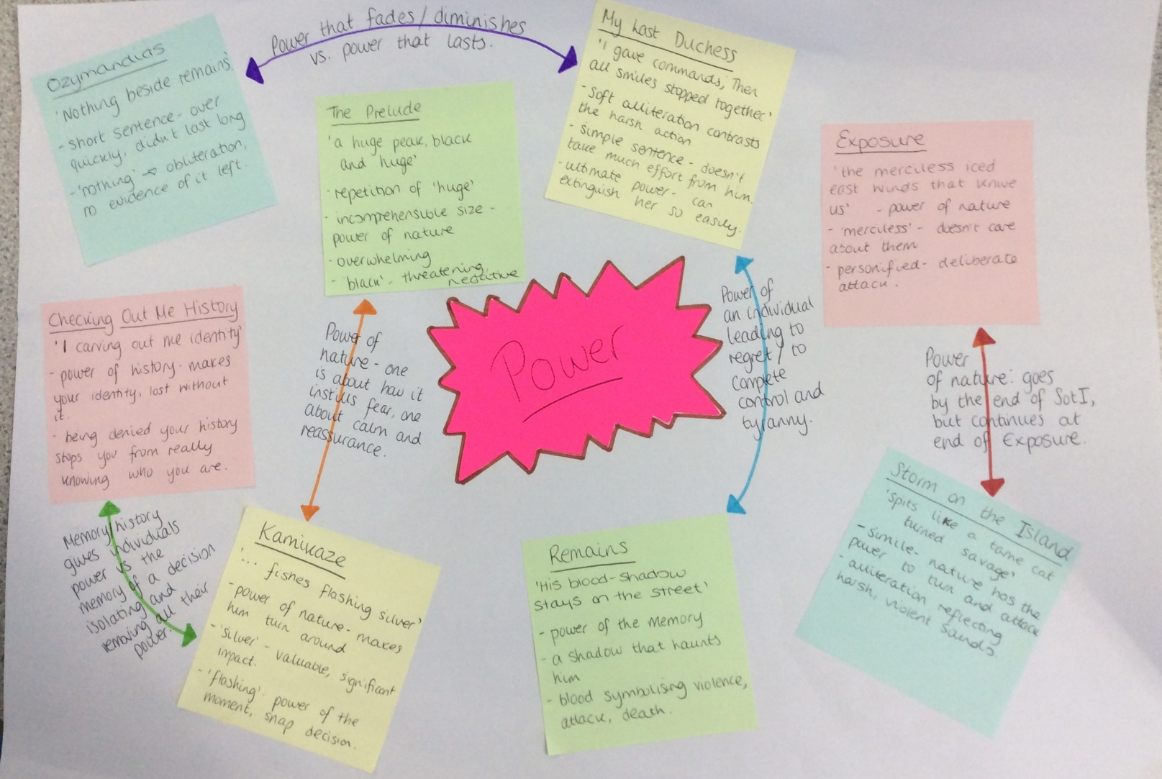

How do I revise for Section C: the unseen poems?

- Familiarise yourself with reading poems that you don’t know and trying to work out the main points and ideas. Always consider the speaker and the poet’s point of view or attitude: what do they think and how do you know this?

- For these questions, you will need to write about the language and structure of the poems. Make sure you know the sorts of things you are looking for:

Language | Structure
Individual words (adjectives, adverbs, verbs) or phrases | Titles
Connotations of the words used | Points where ideas / tone changes
Language devices (similes, metaphors, alliteration etc.) | Enjambment
Capitalised words | Short or long lines
Punctuation for effect (e.g. question marks, ellipsis, exclamation marks) | Short or long sentences
Types of words (subject specific, easy to read, tricky vocabulary) | Short or long stanzas
Do the words match the ideas and content of the poem, or are they unexpected? | Beginnings and endings(first and last lines)
 | Narrative perspective (1st or 3rd person)
 | Rhyme scheme or lack of rhyme

- Complete practice questions – there are some included in this pack. Allow yourself 10 minutes to read through the poem and gather your ideas (use the ladder from suggestion d) to help you) and then write up your response, timing yourself and allowing 30-35 minutes to write.
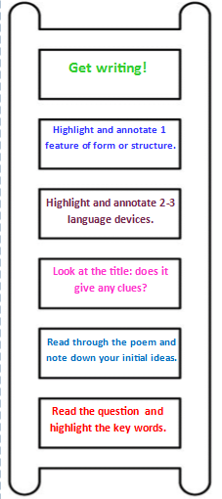
- Use this analysis ladder to help you when approaching an unseen poem. Work through the steps in order. Try using this with a range of different poems, including to revise the anthology poems.

Practice Exam Questions: An Inspector Calls

- How does Priestley present Inspector Goole in An Inspector Calls?

Write about:

- how the Inspector treats and deals with the other characters
- how Priestley presents the Inspector.
[30 marks]
AO4 [4 marks]

- How does Priestley explore the role of women in An Inspector Calls?

Write about:

- the ideas about women presented in An Inspector Calls
- how Priestley presents these ideas by the ways he writes.
[30 marks]
AO4 [4 marks]

Practice Exam Questions: An Inspector Calls
- How does Kelly present Brian as a victim in DNA?

Write about:

- how Kelly presents Brian overall and as a victim
- how Kelly presents and comments on victims overall.
[30 marks]
AO4 [4 marks]

- How does Kelly present ideas about morality in the DNA?

Write about:

- how Kelly the idea of morality through different characters
- how the actions of the characters link to their ideas about morality.
[30 marks]
AO4 [4 marks]

Practice Exam Questions: Power and Conflict poems
- Compare the ways poets present ideas about pride in ‘Ozymandias’ and in one other poem from ‘Power and Conflict’.
[30 marks]

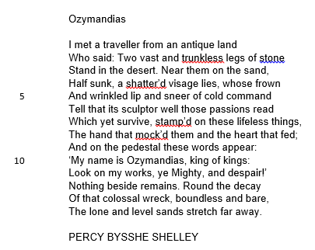

- Compare the ways poets present ideas about anger in ‘London’ and in one other poem from ‘Power and Conflict’.
[30 marks]
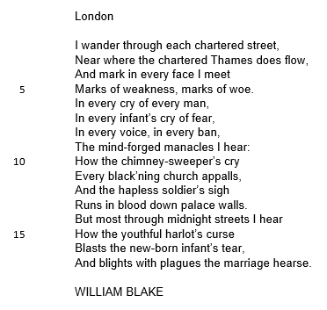

Practice Exam Questions: Unseen Poetry
0.1 In ‘Futility’, how does the poet present the speaker’s feelings about war and the loss of life it involves?
[24 marks]
Futility

Move him into the sun—
Gently its touch awoke him once,
At home, whispering of fields half-sown.
Always it woke him, even in France,
Until this morning and this snow.
If anything might rouse him now
The kind old sun will know.

Think how it wakes the seeds—
Woke once the clays of a cold star.
Are limbs, so dear-achieved, are sides
Full-nerved, still warm, too hard to stir?
Was it for this the clay grew tall?
—O what made fatuous sunbeams toil
To break earth's sleep at all?
Wilfred Owen

0.2 Both ‘Futility’ and ‘Who’s for the Game?’ are about war and soldiers fighting. What are the similarities and differences in the way they present their feelings towards war?
[8 marks]
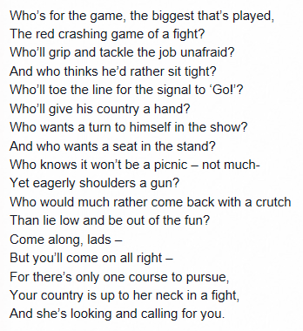
Who’s for the Game?

Jessie Pope

  - In ‘Island Man’, how does the poet present the speakers feelings about places?
[24 marks]

Island Man
Morning
and island man wakes up
to the sound of blue surf
in his head
the steady breaking and wombing
wild seabirds
and fishermen pushing out to sea
the sun surfacing defiantly
from the east
of his small emerald island
he always comes back groggily groggily
Comes back to sands
of a grey metallic soar
to surge of wheels
to dull North Circular roar
muffling muffling
his crumpled pillow waves
island man heaves himself
Another London day
Grace Nichols
0.2 Both ‘Island Man’ and ‘The Vision’ describe places. What are the similarities and differences in the way they present their ideas about these places? [8 marks]

The Vision
The future was a beautiful place, once.
Remember the full-blown balsa-wood town
on public display in the Civic Hall.
The ring-bound sketches, artists’ impressions,
blueprints of smoked glass and tubular steel,
board-game suburbs, modes of transportation
like fairground rides or executive toys.
Cities like dreams, cantilevered by light.
And people like us at the bottle-bank
next to the cycle-path, or dog-walking
over tended strips of fuzzy-felt grass,
or motoring home in electric cars,
model drivers. Or after the late show –
strolling the boulevard. They were the plans,
all underwritten in the neat left-hand
of architects – a true, legible script.
I pulled that future out of the north wind
at the landfill site, stamped with today’s date,
riding the air with other such futures,
all unlived in and now fully extinct.
Simon Armitage

