AQA English Literature
How to Revise for Paper 1:
Shakespeare and the 19th Century Novel

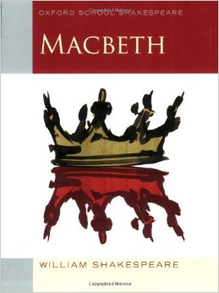
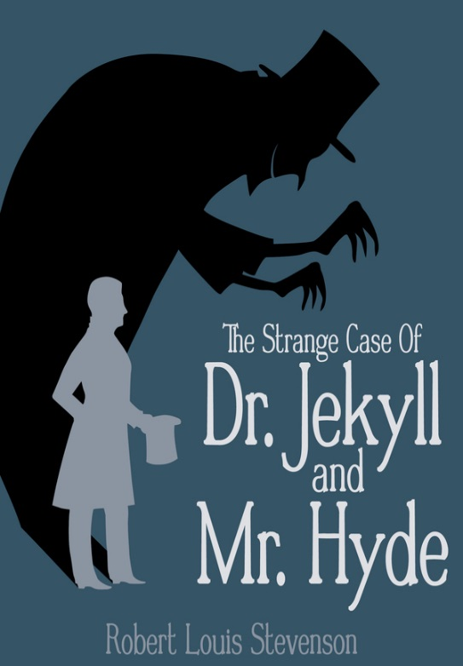
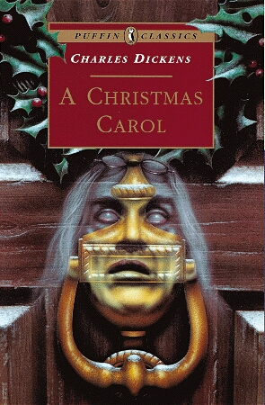
What does the exam involve?

Paper 1 is 1 hour and 45 minutes long and is marked out of 64.
Section A is on Macbeth.
You will be presented with a short extract from the play.
There will only be ONE question on Macbeth – you MUST answer it!
The question will ask you to focus on the extract (examiners expect to see close language analysis) and then relate it to elsewhere in the play, so you can show your understanding of the whole play.

You are advised to spend 45 minutes writing your response to Macbeth and then 5 minutes carefully proof-reading it for SPAG accuracy!

SPAG is marked for your Macbeth answer – so spend 5 minutes checking and correcting any mistakes you might have made when writing against the clock!

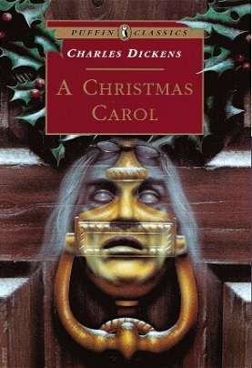
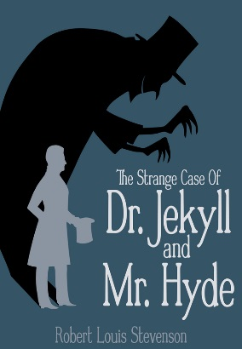
Section B is on either A Christmas Carol or The Strange Case of Dr Jekyll and Mr Hyde.
Answer the question on the text that you have studied in class.
You will be presented with a short extract from the novel.
There will only be ONE question on each text – find the one that you have studied and answer that question.
The question will ask you to focus on the extract (examiners expect to see close language analysis) and then relate it to elsewhere in the play, so you can show your understanding of the whole play.
You are advised to spend 50 minutes writing your response to Macbeth and then 5 minutes carefully proof-reading and editing what you have written.

How do I revise the texts?

- The extract could be from anywhere in the play or novel, so you need to know the whole plot well. You could revise this by:
- using www.sparknotes.com;
- using BBC Bitesize;
- referring to your revision guides (you can buy these from the library).

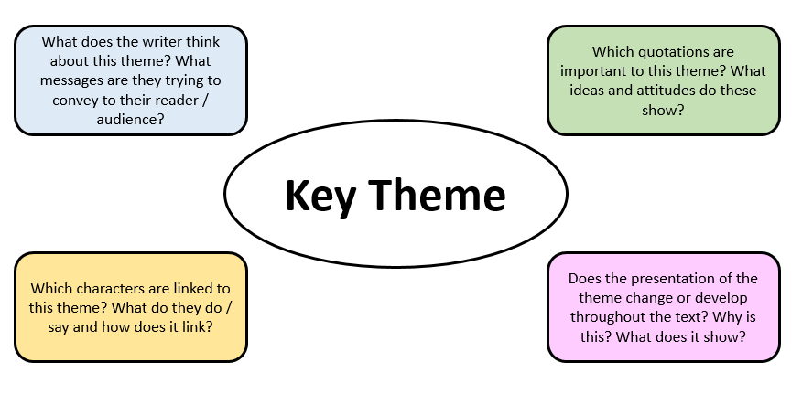
- The question will ask you to focus your analysis on either a theme or on a character from the text. Create revision notes (cue cards, mind maps, profiles) of as many themes and characters as you can. Use the questions on the mind maps below as a starting point.
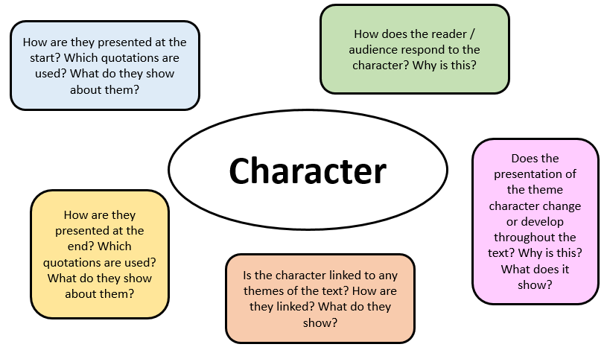
- Practice planning and then answering questions on your set texts. There are example questions for each text at the end of this booklet. You should aim to plan in 5 – 10 minutes and then spend 45 minutes writing your answer.

- Practice annotating extracts from your texts. You can use the practice questions included here, but you could just also select a page from your text and highlight and annotate points in it.

- Create some key quotation cue cards. On one side, write a quotation that links to a range of themes or characters. On the other side, write down as many ideas about the quotation as you can. Don’t forget to consider any language or structural devices, as well as what it shows about themes and characters. Then either test yourself or ask someone else to read out the quotation and see how much you can remember about it.

- Practice speed planning: pick a theme or character and complete a grid like the one on the next page.

English Literature Speed Planning: complete this in 10 minutes.
Select either a theme or a character from your text. This is the focus of your plan.

Bigger picture: how are they presented and if they change, how do they change?
Point and quote 1
Point and quote 2
Point and quote 3
Point and quote 4
Conclusion: three key words to summarise your ideas.

Practice Exam Questions: Macbeth
- Read the following extract from Act 2 Scene 3 of Macbeth and then answer the question that follows.

At this point in the play Duncan’s sons are considering what they should do to be safe after the death of their father, the king.

Exeunt all but Malcolm and Donalbain.
MALCOLM
What will you do? Let's not consort with them:
To show an unfelt sorrow is an office
Which the false man does easy. I'll to England.
DONALBAIN
To Ireland, I; our separated fortune
Shall keep us both the safer: where we are,
There's daggers in men's smiles: the near in blood,
The nearer bloody.
MALCOLM
This murderous shaft that's shot
Hath not yet lighted, and our safest way
Is to avoid the aim. Therefore, to horse;
And let us not be dainty of leave-taking,
But shift away: there's warrant in that theft
Which steals itself, when there's no mercy left.
Exeunt

Starting with this extract, explain how far you think Shakespeare presents fear.
Write about:
• how Shakespeare presents fear in this extract
• how Shakespeare presents fear in the play as a whole.

[30 marks]
AO4 [4 marks]

- Read the following extract from Act 1 Scene 3 of Macbeth and then answer the question that follows.

At this point in the play the witches have met and are now ready to meet Macbeth and deliver his predictions.

ALL (3 witches chant)
The weird sisters, hand in hand,
Posters of the sea and land,
Thus do go about, about:
Thrice to thine and thrice to mine
And thrice again, to make up nine.
Peace! the charm's wound up.
Enter MACBETH and BANQUO
MACBETH
So foul and fair a day I have not seen.
BANQUO
How far is't call'd to Forres? What are these
So wither'd and so wild in their attire,
That look not like the inhabitants o' the earth,
And yet are on't? Live you? or are you aught
That man may question? You seem to understand me,
By each at once her chappy finger laying
Upon her skinny lips: you should be women,
And yet your beards forbid me to interpret
That you are so.

Starting with this extract, explain how far you think Shakespeare presents the witches as unnatural.

Write about:
• how Shakespeare presents the witches in this extract
• how Shakespeare presents the witches and/or other smaller characters in the play as a whole.

[30 marks]
AO4 [4 marks]

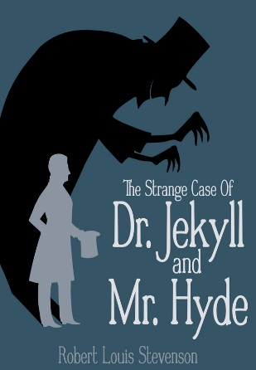
Practice Exam Questions: The Strange Case of Dr Jekyll and Mr Hyde
- Read the following extract from Chapter 1 of The Strange Case of Dr Jekyll and Mr Hyde and then answer the question that follows.

In this extract, the reader is introduced to the character of Mr Utterson.

MR. UTTERSON the lawyer was a man of a rugged countenance, that was never lighted by a smile; cold, scanty and embarrassed in discourse; backward in sentiment; lean, long, dusty, dreary, and yet somehow lovable. At friendly meetings, and when the wine was to his taste, something eminently human beaconed from his eye; something indeed which never found its way into his talk, but which spoke not only in these silent symbols of the after-dinner face, but more often and loudly in the acts of his life. He was austere with himself; drank gin when he was alone, to mortify a taste for vintages; and though he enjoyed the theatre, had not crossed the doors of one for twenty years. But he had an approved tolerance for others; sometimes wondering, almost with envy, at the high pressure of spirits involved in their misdeeds; and in any extremity inclined to help rather than to reprove.
"I incline to Cain's heresy," he used to say quaintly: "I let my brother go to the devil in his own way." In this character, it was frequently his fortune to be the last reputable acquaintance and the last good influence in the lives of down-going men. And to such as these, so long as they came about his chambers, he never marked a shade of change in his demeanour.
No doubt the feat was easy to Mr. Utterson; for he was undemonstrative at the best, and even his friendship seemed to be founded in a similar catholicity of good-nature. It is the mark of a modest man to accept his friendly circle ready-made from the hands of opportunity; and that was the lawyer's way. His friends were those of his own blood or those whom he had known the longest; his affections, like ivy, were the growth of time, they implied no aptness in the object.

- Starting with this extract, what are some of the different ideas Stevenson presents about Mr Utterson?

Write about:
  - how Stevenson presents Mr Utterson in this extract;
  - how Stevenson presents, develops and uses the character of Mr Utterson in the novel as a whole.
[30 marks]
- Read the following extract from Chapter 1 of The Strange Case of Dr Jekyll and Mr Hyde and then answer the question that follows.

In this extract, Mr Utterson recalls the story he has heard of Mr Hyde colliding with a young girl in the street.

All at once, I saw two figures: one a little man who was stumping along eastward at a good walk, and the other a girl of maybe eight or ten who was running as hard as she was able down a cross street. Well, sir, the two ran into one another naturally enough at the corner; and then came the horrible part of the thing; for the man trampled calmly over the child's body and left her screaming on the ground. It sounds nothing to hear, but it was hellish to see. It wasn't like a man; it was like some damned Juggernaut. I gave a view-halloa, took to my heels, collared my gentleman, and brought him back to where there was already quite a group about the screaming child. He was perfectly cool and made no resistance, but gave me one look, so ugly that it brought out the sweat on me like running. The people who had turned out were the girl's own family; and pretty soon, the doctor, for whom she had been sent, put in his appearance. Well, the child was not much the worse, more frightened, according to the Sawbones; and there you might have supposed would be an end to it. But there was one curious circumstance. I had taken a loathing to my gentleman at first sight. So had the child's family, which was only natural. But the doctor's case was what struck me. He was the usual cut-and-dry apothecary, of no particular age and colour, with a strong Edinburgh accent, and about as emotional as a bagpipe. Well, sir, he was like the rest of us; every time he looked at my prisoner, I saw that Sawbones turn sick and white with the desire to kill him. I knew what was in his mind, just as he knew what was in mine; and killing being out of the question, we did the next best. We told the man we could and would make such a scandal out of this, as should make his name stink from one end of London to the other. If he had any friends or any credit, we undertook that he should lose them. And all the time, as we were pitching it in red hot, we were keeping the women off him as best we could, for they were as wild as harpies. I never saw a circle of such hateful faces; and there was the man in the middle, with a kind of black, sneering coolness—frightened too, I could see that—but carrying it off, sir, really like Satan.

- Starting with this extract, how does Stevenson show that importance of people’s judgement of others?

Write about:
  - how Stevenson presents the judgement of Hyde in this extract;
  - how Stevenson presents the judgement of other characters and its consequences in the novel as a whole.
[30 marks]
Practice Exam Questions: A Christmas Carol
- Read the following extract from Stave 4 of A Christmas Carol and then answer the question that follows.

In this extract, Scrooge meets the final spirit to visit him: the Ghost of Christmas Yet to Come.
The Phantom slowly, gravely, silently approached. When it came, Scrooge bent down upon his knee; for in the very air through which this Spirit moved it seemed to scatter gloom and mystery.  It was shrouded in a deep black garment, which concealed its head, its face, its form, and left nothing of it visible save one outstretched hand. But for this it would have been difficult to detach its figure from the night, and separate it from the darkness by which it was surrounded.  He felt that it was tall and stately when it came beside him, and that its mysterious presence filled him with a solemn dread. He knew no more, for the Spirit neither spoke nor moved.  "I am in the presence of the Ghost of Christmas Yet To Come?" said Scrooge.  The Spirit answered not, but pointed downward with its hand.  "You are about to show me shadows of the things that have not happened, but will happen in the time before us," Scrooge pursued. "Is that so, Spirit?"  The upper portion of the garment was contracted for an instant in its folds, as if the Spirit had inclined its head. That was the only answer he received.  Although well used to ghostly company by this time, Scrooge feared the silent shape so much that his legs trembled beneath him, and he found that he could hardly stand when he prepared to follow it. The Spirit pauses a moment, as observing his condition, and giving him time to recover.  But Scrooge was all the worse for this. It thrilled him with a vague uncertain horror, to know that behind the dusky shroud there were ghostly eyes intently fixed upon him, while he, though he stretched his own to the utmost, could see nothing but a spectral hand and one great heap of black.  "Ghost of the Future!" he exclaimed, "I fear you more than any spectre I have seen. But as I know your purpose is to do me good, and as I hope to live to be another man from what I was, I am prepared to bear you company, and do it with a thankful heart. Will you not speak to me?"  It gave him no reply. The hand was pointed straight before them. | 5  10  15  20  25

Starting with this extract, explore how Dickens presents the spirits in his novel.
Write about:
• how Dickens presents the spirit in this extract
• how Dickens presents the spirits overall.
[30 marks]
- Read the following extract from Stave 2 of A Christmas Carol and then answer the question that follows.

In this extract, Scrooge reflects with the Ghost of Christmas Past on the Christmas party thrown by Fezziwig for his employees.
When the clock struck eleven, this domestic ball broke up. Mr and Mrs Fezziwig took their stations, one on either side of the door, and shaking hands with every person individually as he or she went out, wished him or her a Merry Christmas. When everybody had retired but the two prentices, they did the same to them; and thus the cheerful voices died away, and the lads were left to their beds; which were under a counter in the back-shop.  During the whole of this time, Scrooge had acted like a man out of his wits. His heart and soul were in the scene, and with his former self. He corroborated everything, remembered everything, enjoyed everything, and underwent the strangest agitation. It was not until now, when the bright faces of his former self and Dick were turned from them, that he remembered the Ghost, and became conscious that it was looking full upon him, while the light upon its head burnt very clear.  "A small matter," said the Ghost, "to make these silly folks so full of gratitude."  "Small!" echoed Scrooge.  The Spirit signed to him to listen to the two apprentices, who were pouring out their hearts in praise of Fezziwig: and when he had done so, said,  "Why! Is it not! He has spent but a few pounds of your mortal money: three or four perhaps. Is that so much that he deserves this praise?"  "It isn't that," said Scrooge, heated by the remark, and speaking unconsciously like his former, not his latter, self. "It isn't that, Spirit. He has the power to render us happy or unhappy; to make our service light or burdensome; a pleasure or a toil. Say that his power lies in words and looks; in things so slight and insignificant that it is impossible to add and count them up: what then? The happiness he gives, is quite as great as if it cost a fortune."  He felt the Spirit's glance, and stopped.  "What is the matter?" asked the Ghost.  "Nothing in particular," said Scrooge.  "Something, I think?" the Ghost insisted.  "No," said Scrooge, "No. I should like to be able to say a word or two to my clerk just now! That's all." | 5  10  15  20  25

Starting with this extract, how does Dickens present ideas about working life in his novel?
Write about:
- how Dickens presents Fezziwig as an employer in this extract
- how Dickens presents working life elsewhere in the novel.
[30 marks]
The Mark Scheme

The Assessment Objectives
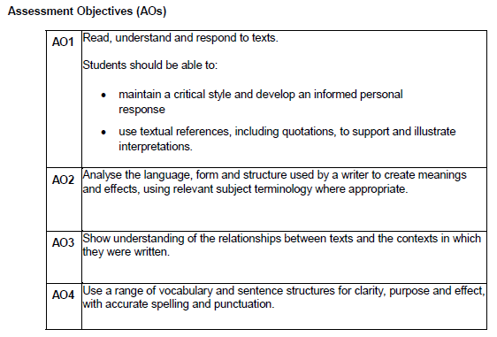
The Mark Scheme: Section A and B
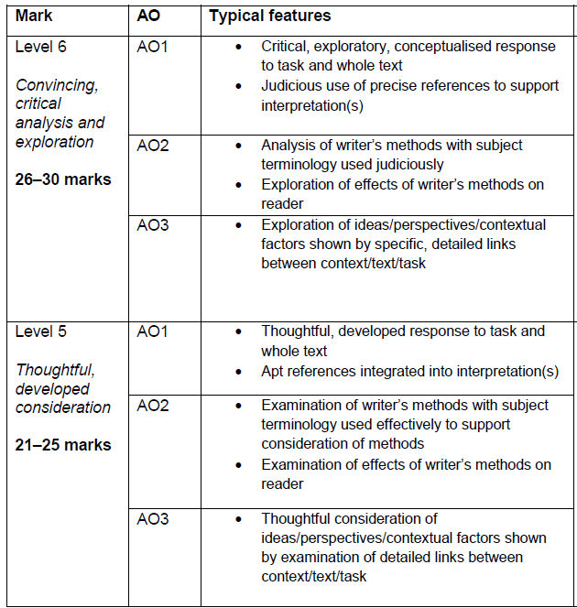
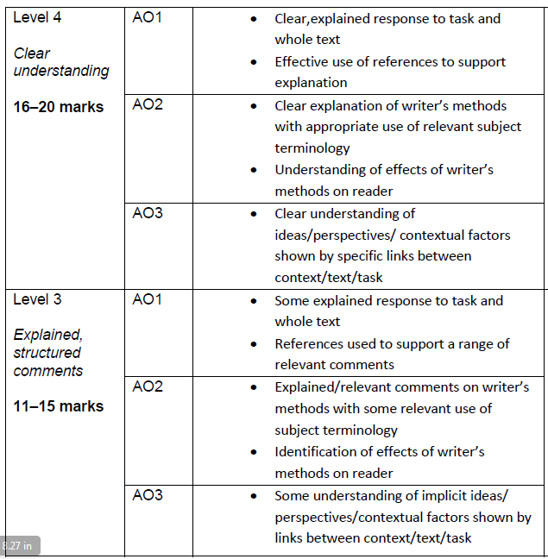
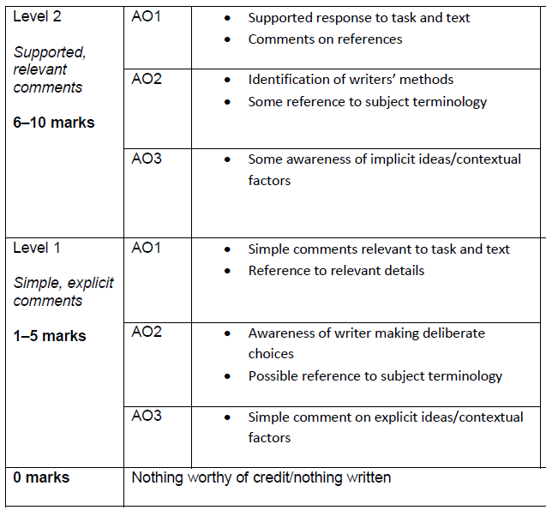

AO4 Mark Scheme: Section A only

