GCSE English Language Paper 2
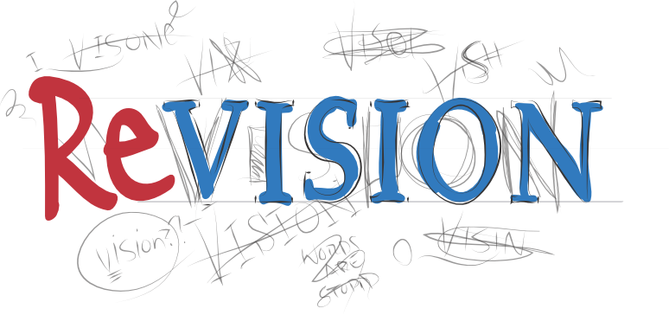

Guide
So you’ve decided that you’d like to revise for the GCSE English Language Paper One exam. This is a very good decision indeed.
This guide is (hopefully) a good place to start, but let’s get what it’s not out of the way…

This guide is not:
- A replacement for all of the good advice and resources that your teachers give you in the lessons.
- A replacement for actually practising the papers; reading this and then thinking you can do it without practising would be very silly indeed.
- A one-size-fits-all framework; your interpretations are really important and crucial to gaining good marks on this paper.
- Totally exhaustive!

What it is designed to be, however, is:
- A reference guide to what you can expect from each of the questions.
- A guide to the mark schemes.
- A hints and tips guide for ways in which you might want to approach and revise the questions.
There will be an accompanying resource with practice questions that you can complete using this guide to help you.

The paper that has been used for examples in this booklet is Specimen One and is the paper in which the extracts are Could you do your child’s homework? and two letters between a father and son regarding boarding school.
Enjoy!

Revision
Steps to revising English Language:
You many have heard this a million and one times before but it’s better to revise little and often.
Step 1: create a revision timetable.
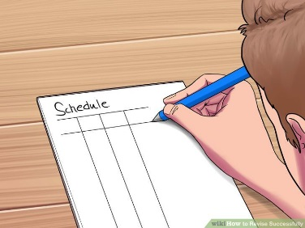
- Make sure you factor in all of your subject requirements and the best time of day for you to revise.
- Schedule in meal and snack times to keep yourself going.
- Be realistic about what you can and will achieve.
- Put English literature and language in different colours to make sure you cover all of the English syllabus.

Step 2: Find the right environment to revise in. NOT in front of the TV. NOT listening to the radio. Music can sometimes be OK, but you need to find the right kind. It's got to be something that's just there in the background that you're not thinking about at all. Music without singing is better as you won't be tempted to dance around your bedroom like a big fool.
- Ensure that remove any distractions when you are revising. EG: hide your phone, turn off the Wi-Fi, etc. You need to focus on the information you are trying to revise.
- Sit at a proper desk. This will be much more comfortable in the long term and will encourage you to be in work mode.
- Some studies show that studying information in different places allows you to compartmentalise the information, making it easier to recall it later if you can associate the information with the location.
- Make sure you drink plenty of water during your revision session.
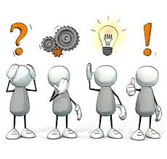
Step 3: Don't put it off!
Start revising as soon as possible and dedicate yourself to it. You can reward yourself afterwards for a productive revision as motivation to get started.
Step 4: actively revise.
Rather than simply reading quickly over the sometimes-dull texts you've got to study, take a more active role. Pick a technique that suits your learning style. By turning your revision into activity you must participate in, you can liven it up a bit and help your memory work more effectively.
- Making Q cards with your own questions/notes on. These cards can then be used for self-testing or get a friend/family member to quiz you. Bright colors help make this bit more fun too as-well as organizing your subjects.
- You could highlight your notes/book/revision guides.
- Create mind maps/summarise the ideas on each page. You can then put these up around your room as a visual reminder.
- TEACH what you've learned to a friend or family member. The best test of knowledge is if you can teach it-remember: "If you can’t explain it simply- you don't know it well enough." (Albert Einstein).
- Write your own exam questions. You could swap these with a friend and then mark each other’s answers using the markscheme.
Step 5: practise, practise, practise.
This will ensure that you feel as calm and confident as possible when you sit down to take the exam. As this is a new exam, there are few examples of exam papers. Therefore, you need to go back over your previous mock papers, classwork and use your revision guides to find example questions. This will ensure you are familiar with exactly what the paper involves.
You will have a better, clearer understanding of the question style and will know exactly how long to spend on each question. It is a good idea to know how long you need to leave for reading, planning and writing in the exam – maybe bring in your own watch so you feel more comfortable.

Useful APPS to download and revise from:
The Paper
Time - One hour and forty-five minutes.
Sections - Two. Section A is reading and Section B is writing.
Marks - 80 marks divided equally between Section A and Section B.
Extracts - Two for use in Section A.
Questions - Five. Four questions in Section A related to the extracts and one in Section B that is an extended writing response based on a prompt.

Timings
(NB- These are advised timings only!)
Section A – 1 hour
0-15 Minutes - Read through the sources and all of the questions that you will have to answer in this paper. This should be spread across the whole of section A.
5 Minutes - Answer question one.
10 Minutes - Answer question two.
10 Minutes - Answer question three.
20 Minutes - Answer question four.
Section B – 1 hour
5 Minutes - Plan question five response.
35 Minutes - Answer question five.
5 Minutes - Proofread question five response.
Revision Tips:
- Revise the timings for the exams.
- When you get your official exam timetable, work out what times you will need to finish the reading section and then start the writing section by.
- Use a stopwatch to help you time how long it takes you to complete responses.
- Practise answering questions within the specific time limits.
Question one has the fewest marks available on the paper and should ‘ease you in’. It requires you to read Source A and then select four correct statements from the list. Make sure that you check

The question looks like this:
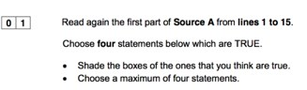
You’ll notice that it asks for your answers to relate only to a specific part of the text. It’s really important that you pay attention to this. Likewise, you must only select four options. If you select more than four, the examiner will mark the first four (regardless of whether the later answers are correct).
The answers to the above question are:
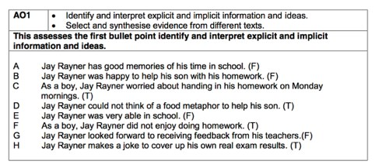

Top Tips for Question One
- Check the specified lines and always answer from within those lines.
- Only select four answers.

How to practise Question One
- Complete practice papers and tasks.
- When reading an article/opening of a chapter/opening of a novel, think about what four key points you could gather from the first few lines.

Question two carries eight marks and requires you to look at two extracts and compare them. It requires you to interpret both implicit and explicit information.
The question looks like this:
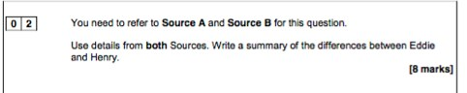
You will notice that the question requires you to use details from the whole of both sources rather than from specified sections. The question is looking for you to include implicit and explicit information. Explicit information is information that is clearly stated in the text and implicit information is information that is implied but not explicitly stated.
You need to use quotations that support your points, but you do not need to analyse language for this question.
Whilst you don’t need to fill all of the space that they give you in the exam paper, this question does require an extended answer in order to meet all of the success criteria for the top band.
The mark scheme for this question is below. This makes it clear that, in order to achieve top marks, you must:
- Show perception in your statements of similarities and/or differences.
- Use apt supporting quotations that are directly relevant to the question
- Use inference as well as include explicit information

What do the exam board say about this question?
- Be perceptive and focus on implicit and explicit information.
- You are not rewarded for the number of quotes you use but for how good your response is and how relevant the quotes are.
- You should be selective about the quotes you use; you should only use quotes about which you can infer something.
- Remember that it is an eight mark question. Therefore, you shouldn’t try to include too many examples and end up treating them superficially.

1-2 Marks | A 1-2 mark response will show simple awareness from one or both tests. It will offer paraphrase rather than inference, will make simple references and show simple differences between texts.
 | Eddie takes the mickey out of his dad but Henry is more polite, ‘respectful son’.
3-4 Marks | A 3-42 mark response will go a little further and show some interpretation from one or both tests. It will attempt some inference, will make some appropriate references and show some differences between texts.
 | Eddie is quite cheeky, ‘You can’t think of one, can you?’ whereas Henry is much more polite, ‘Your respectful son’ suggesting he is really trying to persuade his dad to let him come home.
5-6 Marks | A response that gains 5-6 marks will be more developed and show clear synthesis and interpretation of both texts. It will make clear inferences from both texts, will select clear, relevant references and show clear differences between texts.
 | Eddie is really cheeky as he speaks to his father in a ‘mocking voice’ showing he is not afraid of him., but Henry is much more formal and respectful, ‘my dear Father’, showing he may be somewhat afraid of him.

For example, top marks will be awarded to responses in which comments are perceptive and detailed.
Read through the response and annotate it, considering what the candidate does well and how they meet the success criteria.

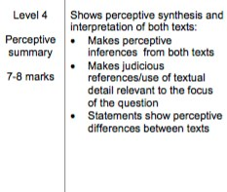
Eddie is quite academic and so is Henry but Eddie doesn’t seem to try particularly hard. ‘He’s irritatingly good at it’ and ‘he is too busy killing this while talking on Skype!’ This suggests that he wants to do well, and does do well, without trying very hard and is living in comfort.
Whereas Henry is having a very uncomfortable time at boarding school, ‘our bread is nearly black’, suggesting they have very scarce or low quality food but Henry works hard and looks after himself unlike Eddie. Henry also does not have his father’s support as Eddie does. Eddie just ignores his father as he comes into the room but Henry is pleading to see his father at all. ‘If God permit me to live as long’, this shows that Henry is basically saying how desperate he is. This contrasts with Eddie who doesn’t realise how lucky he is.

Top Tips for Question Two
- Remember to include inferences.
- Use quotes to support your answers.
- Focus on ensuring that you are communicating the differences between the texts.

How to practise Question Two
- Complete practice papers and tasks.
- Use the unseen resources in the accompanying resource booklet to practise close analysis of the effects of language.
- Compare images of from the nineteenth century to a similar thing in the twenty first century. EG: an abacus and a calculator; a steam train and a high speed train; a Victorian hospital and a modern hospital. Remember to make inferences.

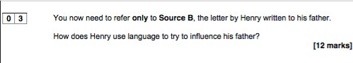
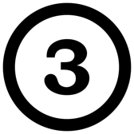
Question three carries twelve marks but, unlike question two requires you to focus on only one extract. It requires you to look in detail at the effect of the language. The question looks like this-

You will notice that, unlike the analysis questions in Paper One, there are no bullet points offered to help you.
The question tells you which part of Source B to refer to; make sure that you focus on the right section!
Again, you don’t have to fill all of the available space but very short answers will be self-penalising as they won’t give you space to explore your points in detail.

Analysis of language can include words, phrases, language features, language techniques and sentence forms.
What do the exam board say about this question?
- Students need to focus on the whole text in their response to this question.
- Responses that describe rather than analyse will attain the lowest marks on this question.
- Responses that elaborate on points with reference to the some of the effects of language will attain middle marks.
- Top marks will be awarded to responses that link the use of language, how it’s effective and the effect that it has in a complex and detailed way.
A top band response:
- Analyses the effects of the writer’s choices of language.
- Uses a range of relevant quotations.
- Uses subject terminology accurately.

Read through the response and annotate it, considering what the candidate does well and how they meet the success criteria.
He uses proper nouns such as ‘August’, ‘October’ and ‘Xmas’ as well as
‘Cotherstone’ and ‘Islington’ to create a sense of time and place and to emphasise to his father the length of time that they have been apart and the distance between them. He adds to this with the use of other phrases linked to time and separation such as ‘It is now two years’ and ‘since I left you’ to create an emotive appeal on his father, and also creates a real sense of his isolation and homesickness. In addition to the proper nouns, Henry also capitalises other words such as ‘Letter’ and ‘Friend’ as though to inflate their importance and point out to his father how much he is in need. He also uses this device later in the letter when he is pointing out the faults of the academy ‘Barley Meal’ and ‘Beds’ to highlight his hardship.
Henry uses direct address to his father which suggests familiarity, ‘you will not let…’, ‘you will let me come home’ and shows how his future is in the hands of his father, but this is also contrasted with a much more distant and formal mode of address, ‘my dear Father’. This phrase is repeated in a number of places as an emotional tool to try and reinforce that his father is ‘dear’ to him - though the distance and time lapse of them being together suggest to the reader that this may not be so - and is a deliberate choice by Henry to appeal to his father.
The formal tone is continued in complex phrases such as ‘If you recollect’, ‘pray don’t mention’, ‘I assure you’ and ‘would be obliged’ with are like persuasive, rhetorical devices designed to make the letter a very polite and respectful request. In some ways, these seem to emphasise the distance between them. This contrasts to the simple use of ‘unhappy’ - a childlike word - and ‘good’, ‘kind’, ‘Friend’, which are applied to Mr Hamler. These simple adjectives seem to suggest that these simple things are all that Henry wants.
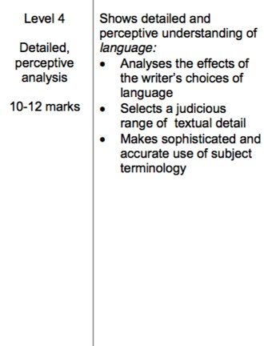
Henry also uses simple descriptive language to point out the faults of his school, ‘nearly black’, ‘worst Barley Meal’, ‘stuffed with chaff’. However, he does on to use a rather hyperbolic simile ‘used more like Bears…Christians’ to try and convince his father they are being treated inhumanely. Additionally, the letter employs a semantic field of religion referring to ‘church’, ‘if God permit me’. Henry seems to be using this as an influence on his father, perhaps reminding his father to act in the way his religion tells him to. Henry again uses hyperbole in the dramatic phrase ‘if God permit me to live as long’ aiming to convince his father that his life is at risk in the school.

Top Tips for Question Three
- Remember to write about the whole of the source.
- Use quotes to support your answers.
- Focus on analysis of the effects of language. Remember ‘how’ and ‘why’. Think of it like the close analysis of poetry,

Question four carries sixteen marks and is the highest tariff question in the reading section of Paper Two. It is focussed on both sources and requires you to respond to a given statement. It requires an extended response and you need to compare the perspectives of both writers and how they’re conveyed. The question looks like this-

How to practise Question Three
- Complete practice papers and tasks.
- When working on and revising your Literature texts, remember that this analytical skill is also relevant for this question on this paper.
- Use the unseen resources in the accompanying resource booklet to practise close analysis of the effects of language.
- As you read a variety of texts during your revision, create a word bank of new vocabulary and their definitions.

- Create synonym explosion posters – pick a word for the middle of the mindmap and around the edge add as many other words that could mean the same thing (synonyms). To develop this further you should comment on the effect of those words.

There are some bullet points that help you think about what to focus on in your points. Remember to check which parts of the sources you are supposed to refer to.
The mark scheme for this question is below -

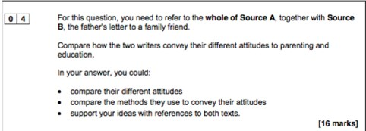
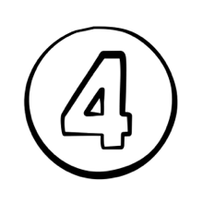
What do the exam board say about this question?
- The question requires you to compare the different attitudes or viewpoints, perspectives and ideas.
- It also wants you to consider how the writers present these to the reader, either their intended reader in the time period in which it is written or the effect on you as the reader of the source.
- As it is a critical evaluation, you shouldn’t simply narrate the piece.
- The board are very clear that you must focus your response around the statement given and they also provide bullet points to help you structure your response.
- The board state clearly that this is meant to be the most challenging question on the paper so don’t panic if you find it more difficult than the previous eight-mark questions.
- Overall, you should compare the writers’ different attitudes and the methods they use to convey these attitudes, and support your ideas with quotations from both texts.

1-4 Marks | A 1-4 mark response will show simple, limited comments. It will make simple cross reference of ideas and perspectives. It will make simple identification of writers’ methods, use simple references from one or both texts and show simple awareness of ideas and/or perspectives.
 | Jay Rayner seems like a laid back father who doesn’t mind his son taking the mickey, ‘remorselessly taking the mickey’. The other father is not that nice and does not even write to his son. It’s like he doesn’t care.
5-8 Marks | A 5-8 mark response will show some attempts at comparison. It will attempt to compare ideas and perspectives and make some comment on how writers’ methods are used. It will selection some appropriate quotations but they won’t necessarily always be supporting. It will identify some different ideas and perspectives.
 | Jay Rayner is a cool parent who has a good sense of humour around his son. He is quite impressed with his son’s education. We know this when it says ‘He got 20 out of 25, or 80%’ whereas Henry’s father is not impressed, ‘In Henry’s letter I see several words wrong-spelt’.
9-12 Marks | A response that gains 11-15 marks will show clear and relevant comparison. It will compare ideas and perspectives in a clear and relevant way and explain clearly how writers’ methods are used. It will select relevant supporting details and will show a clear understanding of the different ideas and perspectives in both texts.
 | Jay Rayner presents his attitude to parenting in a humorous way when he says ‘They grow up… Take the mickey out of you’ whereas Henry’s father is much more distant and seems to want to have both of his sons well out of the way.
13-16 Marks | Summarise in your own words, what the pupil below does well to achieve 13-16 Marks. Use the mark scheme below to help you.  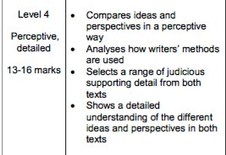
On the next page is a section from a response that would attain thirteen or fourteen marks on this question. Read through the response and annotate it, considering what the candidate does well and how they meet the success criteria as well as how they could secure marks at the top of the top band.
Jay Rayner clearly has a much closer relationship with his son than Henry’s father in Source Two. There is a physical closeness in that Rayner and his son live in the same house and share everyday life and concerns, whereas Henry lives away from his father at boarding school and rarely comes home, ‘It is now two years come October that I left you at Islington’. This means that Henry’s father has no real idea of Henry’s everyday life and concerns, apart from the occasional letter.
Jay Rayner clearly empathises with his son’s concerns, including homework, and decides to ‘share a little solidarity’ by attempting his maths homework. While Henry’s father has to rely on the intervention of a friend to find out more about Henry’s problems and asks him to ‘ascertain whether you think it would be advisable for me to send for them home’.
Jay Rayner writes in an informal tone, which matches his relaxed and more modern approach to parenting. He talks about children such as his who ‘take the mickey’ out of their parents. Henry’s father uses a much more formal tone with his choices of language, ‘induced to write to you’, ‘excuse the liberty I take’, which reflects the language of the time the letter was written. The letter was not even written to his son, but to a friend.
Both fathers seem to value education but have different approaches to their sons’ learning.
Jay Rayner uses humour to convey his own moderate academic achievement. He confessed that his ‘grades lined up like a line of Pac-Men doing a conga’. He also uses humour to express his pride at his son’s educational achievements in Maths when he describes him as being ‘irritatingly good at it’. ‘Irritatingly’ reflects Rayner’s wonder at his son’s natural talent while he struggles.
Henry’s father is very concerned about his sons’s education, particularly his spelling, ‘I see several words wrong-spelt’. This is ironic as the father has made grammatical mistakes himself. He is unaware of his educational weaknesses, whereas Rayner makes a joke.

T

op Tips for Question Four
- Remember to write about the specified parts of the sources.
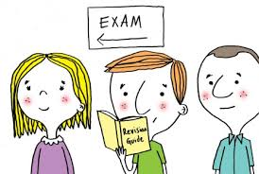
- Use quotes to support your answers.
- Focus on comparison and analysis.
- Remember that this is a detailed, analytical response.

How to practise Question Four
- Complete practice papers and tasks.
- When working on and revising your Literature texts, remember that many of the skills are transferable.
- Use the unseen resources in the accompanying resource booklet to practise writing evaluative essays based on statements from readers.

Specimen Paper Inserts

Source A – 21st Century non-fiction
Could you do your child's homework?
The Observer, Sunday 15 December 2013

Children appear increasingly weighed down by homework. But how tough can it be? Jay Rayner attempts his son Eddie's maths assignment.

A typical father son scenario

I am staring at a finely printed sheet of paper and trying not to let the bad feelings seep in. This sheet is all my childhood Sunday-night feelings of dread come at once. It is humiliation and "could do better" and "pay attention now".

I only have myself to blame. A few months ago over dinner Eddie announced that, in 5 English, they were experimenting with food writing. "I have to come up with metaphors. Give me a metaphor about this pizza," he said. "I don't think I should do your homework for you," I said. He raised his eyebrows. "You can't think of one, can you?" This is what happens if you feed and educate your children. They grow up, become clever and remorselessly take the mickey out of you.

He was right. I didn't. On the spot I couldn't think of a single food metaphor worth dragging out and slapping on the table. And so the memories of homework came flooding back: of long nights of carefully planned idleness ruined by the imposition of essays and work sheets, of tasks flunked, of a chilly emptiness at the thought of the way my efforts would be received by teachers. The fact is that I was not especially academic. On the results sheet, my grades lined up like a line of Pac-Men¹ doing a conga².

And so, having failed the English homework test, I decide to show a little solidarity. I will have a go at his maths homework just to get a sense of what it's like to be 14-year-old Eddie. Which is why I'm now staring at the sheet of paper. Ah yes, algebra, the merry dance of x and y. Simplify. Wrench things out of brackets. Calculate values. This, I used to be able to do. Or at least I think I used to be able to do this.

Hmmm. Right. Yes. I mean… I stare at the page again, wondering whether I might be able to will a nosebleed to obscure the equations. There are three marks out of a total of available here. Not getting it right would be an early setback.

The next one looks more straightforward. a⁴ x a³. I'm pretty sure I remember this. Just add the powers together. Which would mean…

There is an "expand and simplify" question, which refuses to grow or be simple. In his special mocking voice, Eddie tells me just to draw a sad face. I do as I'm told. Better that than a blank. Eddie returns to his room and I press on. Some of them I can manage. I appear to know how to multiply out 3 (5-2x). But with the next one I am firmly back in the 30 weeds. I am so baffled that, shamelessly, I Google a maths website.

A few days later Eddie receives his marks. He got 20 out of 25, or 80%, a low score for him. Me? I've got 12 out of 25, or less than 50%. Does it need saying that my biggest miscalculation was to take on Eddie over maths? He doesn't labour the point but he’s irritatingly good at it. I knock on his bedroom door. He doesn't look up from his computer screen. He is too busy killing things, while talking on Skype to his friend Theo, who is also in the game trying to kill the same things.

Finally he looks up at me from the computer. Who needs teachers to humiliate you when your son can do it so effectively?
Glossary:
Pac-Man¹ – a popular computer game in the 1980’s in which the character follows the lines of a maze to collect points as it goes.
conga² – a dance in which participants follow behind a leading person in a long line.

Source B – 19th Century literary non-fiction

This Source consists of two letters. The first letter is from a young boy called Henry writing to his father. Henry is living far away from home at a boarding school. A boarding school is a school where you go to live as well as study and was a very popular way of educating boys, especially from wealthier families, in the 1800s.

5  10  15  20 | Cotherstone Academy Aug. 7. 1822  Dear Father  Our Master has arrived at Cotherstone, but I was sorry to learn he had no Letter for me nor anything else, which made me very unhappy. If you recollect, I promised that I would write you a sly Letter, which I assure you I have not forgot, and now an opportunity has come at last. I hope, my dear Father, you will not let Mr. Smith know anything about it for he would flog me if he knew it. I hope, my dear Father, you will write me a Letter as soon as you receive this, but pray don’t mention anything about this in yours; only put a X at the bottom, or write to my good Friend Mr. Halmer, who is very kind to me and he will give it to me when I go to Church. He lives opposite and I assure you, my dear Father, they are the kindest Friends I have in Yorkshire and I know he will not show it to Mr. Smith for the Letters I write you are all examined before they leave the School. I am obliged to write what Mr. Smith tells us and the letters you send me are all examined by Mr. Smith before I see them, so I hope, my dear Father, you will mention nothing of this when you write.  It is now two years come October since I left you at Islington, but I hope, my dear Father, you will let me come home at Xmas that we may once more meet again alive - if God permit me to live as long.  Our bread is nearly black; it is made of the worst Barley Meal, and our Beds are stuffed with chaff¹ and I assure you we are used more like Bears than Christians². Believe me, my dear Father, I would rather be obliged to work all my life time than remain here another year.  George is quite well but very unhappy.  Your respectful son  Henry
The second letter, written two weeks later, is from the boy’s father to a family friend, asking him to investigate the problem. The father has two sons at the school, Henry and George.

25  30  35  40  45  50 | Public Office, Worship Street, 21st August 1822.  Sir,  Having lately received a Letter from my Son Henry, who is at Mr. Smith’s School close by you, complaining of the Treatment he receives, I am induced to write to you, confidentially, to request you will do me the favour to endeavour to see both of them, privately, (at your own House) if possible and ascertain whether you think it would be advisable for me to send for them home. I will certainly be guided by what you say; Boys will sometimes complain without cause, and therefore I hope you will excuse the liberty I take in troubling you. Henry speaks very highly of your kind attention.  I do not approve of the System of Education, for they do not appear to have improved. When they left home, they could both spell, and in Henry’s Letter I see several words wrong spelt – I also do not like the injunction laid upon them of not being allowed to write to me without the Master’s seeing the contents of their Letters.  If you should not be able to get a private interview with them in the course of a fortnight, I shall be obliged by your writing to me to say so and I will immediately give notice to Mr. Smith that I intend to have them home at Christmas. I should prefer your seeing George if you can, and hear what he says, as I can rely more on the truth of his story, than Henry’s, for I believe Henry’s principal object is to get home. We have all a great desire to see him, but particularly to see George, our other son, who is a meek Boy and not so able to endure ill treatment as Henry – George is a great favourite with us all, and so he was with his late dear Mother who is now no more.  You will no doubt see my object in thus troubling you and I hope you will excuse the liberty I take, but as I know you have been very kind to the Boys. I shall esteem it an additional favour by your attention to this, and an answer at your earliest convenience.  I remain Sir, very respectfully  Your obliged honorable servant  William Heritage

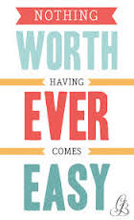
Glossary:
chaff¹ – chopped straw or hay.
Bears than Christians² – bears were sometimes mistreated, perhaps suggesting he feels he’s being treated more like an animal than a human being, or in a Christian way.

