GCSE English Language Paper 1
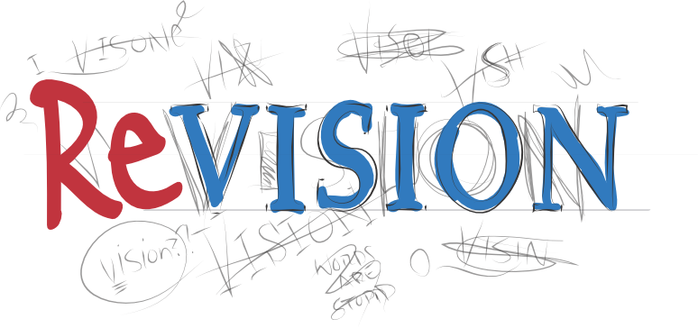

Guide
So you’ve decided that you’d like to revise for the GCSE English Language Paper One exam. This is a very good decision indeed.
This guide is (hopefully) a good place to start, but let’s get what it’s not out of the way…

This guide is not:
- A replacement for all of the good advice and resources that your teachers give you in the lessons.
- A replacement for actually practising the papers; reading this and then thinking you can do it without practising would be very silly indeed.
- A one-size-fits-all framework; your interpretations are really important and crucial to gaining good marks on this paper.
- Totally exhaustive!

What it is designed to be, however, is:
- A reference guide to what you can expect from each of the questions.
- A guide to the mark schemes.
- A hints and tips guide for ways in which you might want to approach and revise the questions.
There will be an accompanying resource with practice questions that you can complete using this guide to help you.

The paper that has been used for examples in this booklet is Specimen One and is the paper in which the extract is taken from Jamaica Inn by Daphne du Maurier.
Enjoy!

Revision
Steps to revising English Language:
You many have heard this a million and one times before but it’s better to revise little and often.
Step 1: create a revision timetable.
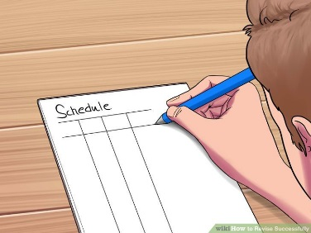
- Make sure you factor in all of your subject requirements and the best time of day for you to revise.
- Schedule in meal and snack times to keep yourself going.
- Be realistic about what you can and will achieve.
- Put English literature and language in different colours to make sure you cover all of the English syllabus.

Step 2: Find the right environment to revise in. NOT in front of the TV. NOT listening to the radio. Music can sometimes be OK, but you need to find the right kind. It's got to be something that's just there in the background that you're not thinking about at all. Music without singing is better as you won't be tempted to dance around your bedroom like a big fool.
- Ensure that remove any distractions when you are revising. EG: hide your phone, turn off the Wi-Fi, etc. You need to focus on the information you are trying to revise.
- Sit at a proper desk. This will be much more comfortable in the long term and will encourage you to be in work mode.
- Some studies show that studying information in different places allows you to compartmentalise the information, making it easier to recall it later if you can associate the information with the location.
- Make sure you drink plenty of water during your revision session.
Step 3: Don't put it off!
Start revising as soon as possible and dedicate yourself to it. You can reward yourself afterwards for a productive revision as motivation to get started.
Step 4: actively revise.
Rather than simply reading quickly over the sometimes-dull texts you've got to study, take a more active role. Pick a technique that suits your learning style. By turning your revision into activity you must participate in, you can liven it up a bit and help your memory work more effectively.
- Making Q cards with your own questions/notes on. These cards can then be used for self-testing or get a friend/family member to quiz you. Bright colors help make this bit more fun too as-well as organizing your subjects.
- You could highlight your notes/book/revision guides.
- Create mind maps/summarise the ideas on each page. You can then put these up around your room as a visual reminder.
- TEACH what you've learned to a friend or family member. The best test of knowledge is if you can teach it-remember: "If you can’t explain it simply- you don't know it well enough." (Albert Einstein).
- Write your own exam questions. You could swap these with a friend and then mark each other’s answers using the markscheme.
Step 5: practise, practise, practise.
This will ensure that you feel as calm and confident as possible when you sit down to take the exam. As this is a new exam, there are few examples of exam papers. Therefore, you need to go back over your previous mock papers, classwork and use your revision guides to find example questions. This will ensure you are familiar with exactly what the paper involves.
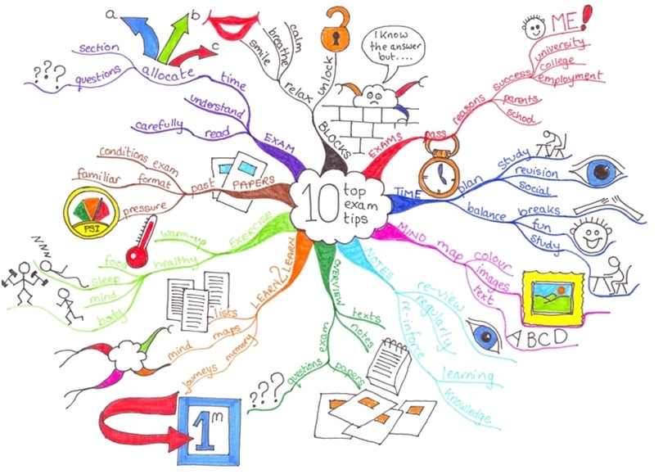
You will have a better, clearer understanding of the question style and will know exactly how long to spend on each question. It is a good idea to know how long you need to leave for reading, planning and writing in the exam – maybe bring in your own watch so you feel more comfortable.
The Paper
Time - One hour and forty-five minutes.
Sections - Two. Section A is reading and Section B is writing.
Marks - 80 marks divided equally between Section A and Section B.
Extracts - One for use in Section A.
Questions - Five. Four questions in Section A related to the extract and one in Section B that is an extended writing response based on a picture or text prompt.

Timings
(NB- These are advised timings only!)
Section A – 1 hour
0-15 Minutes - Read through the source and all of the questions that you will have to answer in this paper. This should be spread across the whole of section A.
5 Minutes - Answer question one.
10 Minutes - Answer question two.
10 Minutes - Answer question three.
20 Minutes - Answer question four.
Section B – 1 hour
5 Minutes - Plan question five response.
35 Minutes - Answer question five.
5 Minutes - Proofread question five response.
Revision Tips:
- Revise the timings for the exams.
- When you get your official exam timetable, work out what times you will need to finish the reading section and then start the writing section by.
- Use a stopwatch to help you time how long it takes you to complete responses.
- Practise answering questions within the specific time limits.
Question one has the fewest marks available on the paper and should ‘ease you in’. It requires you to read the extract and take four pieces of specific information from it.

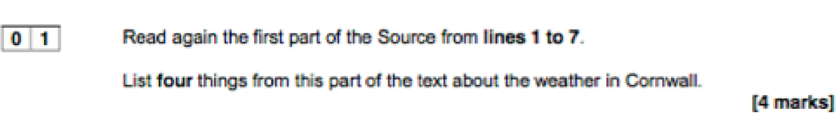
The question looks like this:

You’ll notice that it asks for your answers to be drawn only from a specific part of the text. It’s really important that you pay attention to this as you won’t get marks for information taken from outside of the specified lines.
There will always be more than four relevant points in the specified lines but you should only select four.
You can quote or write the point in your own words; both of these are acceptable and you will gain marks for both.
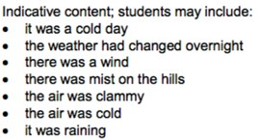
The answers the exam board suggest for the question above are:

Top Tips for Question One
- Check the specified lines and always answer from within those lines.
- Quote or paraphrase.
- Only write four answers.

How to practise Question One:
- Complete practice papers and tasks.
- When reading an article/opening of a chapter/opening of a novel, think about what four key points you could gather from the first few lines.
- Ask parents and friends to ask you to identify four facts from a range of every day texts (newspaper, web article, cereal box etc.). You could even practise this skill while watching the TV or a film.

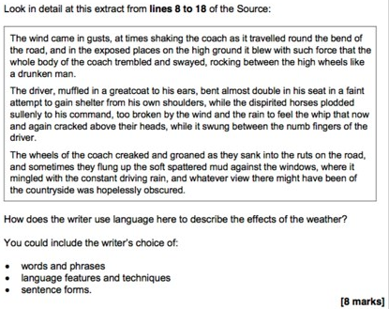
Question two is worth eight marks and requires you to look at the detail of the extract and analyse the effects of language. The question looks like this:

You will notice again that the question requires you to focus on a specific section of the text. The section of the text that you should analyse for this question will be printed above it and it is very important that you only focus on this part of the extract for this question.

There will be bullet points underneath the question that will guide you towards points to focus on; make sure that you don’t ignore these!

Analysis of ‘language’ has been extended in these exams to allow you to talk about sentence forms as well as specific words and phrases.

Overall, the question wants you to analyse the ways in which the writer uses language to achieve effects and influence you as a reader.

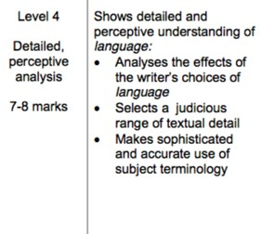
Whilst you don’t need to fill all of the space that they give you in the exam paper, this question does require an extended answer in order to meet all of the success criteria for the top band. (Aim for three PEEE paragraphs).

The mark scheme for this question is below. This makes it clear that, in order to achieve top marks, you must:
- Be analytical
- Focus wholly on the effects of language
- Use a range of appropriate, well-chosen quotations
- Use accurate terminology

What do the exam board say about this question?

- Students should consider the effects on the reader and how they are created.
- Responses that describe rather than analyse will attain the lowest marks on this question.
- Responses that elaborate on points with reference to how the language techniques work will attain middle marks.
- Top marks will be awarded to responses that link the use of language, how it’s effective and the effect on the reader in a complex and detailed way.
For example, top marks will be awarded to responses in which comments are perceptive and detailed.
A top band response-
- Shows detailed and perceptive understanding of language
- Analyses the effects of the writer’s choices of language
- Selects a judicious range of relevant quotations
- Uses sophisticated subject terminology accurately

You can consider things like the use of sentence length, the use of nouns and verbs to enhance description, the effect of words and phrases and how they build on each other, and imagery and techniques used.

1-2 Marks | A 1-2 mark response will show simple awareness of language. It will offer simple comment on the effect of language and support these with simple quotations.
 | The writer says ‘The wind came in gusts at times shaking the coach’. The word ‘gusts’ emphasises that sometimes the wind was strong and was making the coach shake.
3-4 Marks | A 3-4 mark responses will go a little further in its attempts to comment on the effects of the language. There will be selection of more appropriate quotes and some use of technical terms will be used.
 | The writer says ‘The wind came in gusts at times shaking the coach’. The word ‘gusts’ emphasises that sometimes the wind blew stronger than others and was making the coach shake or shudder. The phrase ‘shaking the coach’ has the effect of making us feel frightened for the passengers because you shake when you are afraid.
5-6 Marks | A response that gains 5-6 marks will be more developed and show clear understanding of the language. It will explain clearly the effects of the writer’s language. There will be a range of relevant quotes used and there will be accurate use of technical terms.
 | The opening, complex sentence is long as so gives the effect of a never-ending storm. Then nouns like ‘gusts’ and ‘force’ are used to show the reader how unpredictable and strong the wind was. The effect of the wind on the coach is built up by the writer’s use of verbs - ‘shaking’ then ‘trembled’ then ‘swayed’. The word ‘trembled’ makes it sound as if the coach is almost frightened of the weather.
7 or 8 marks | Below is a section of an answer that would attain on this question. Read through the response and explain what the candidate does well and what they have doen to achieve a mark in this band.
Du Maurier demonstrates how boring the day is through her careful use of adjectives such as ‘cold’ and ‘grey’ both of these have connotations of lifeless experiences which may be what Du Maurier is trying to create. Du Maurier’s use of pathetic fallacy suggested a mysterious and negative day is upon us by using ‘the weather had changed overnight’, this shows the atmosphere is changing, becoming darker and more cynical. The short syntax at the start of the opening emphasises the simplicity of that statement in an attempt to show the basis of the day in a way to engage the reader from the start. The personification of the mist suggests even natural elements are negative in this area as it has ‘cloaking them in mist’, this would shroud and hinder people which is a mean thing to do. As well as this ‘cloaking’ suggests they need to be concealed possibly making them mysterious and therefore we threat them with suspicious.
The second short sentence creates a tense atmosphere and a sense of anticipation as ‘it would be dark by four’ suggesting the dark holds something unexpected which will causes the reader to believe the day will continue to evolve and become very dramatic when it is dark. Du Maurier creates the day as omnipotent and intrusive as she uses the verb ‘penetrated’ which suggests there is no escape from the menacing day.

Top Tips for Question Two
- Check the specified lines and always answer from within those lines.
- Use quotes to support your answers.
- Focus on analysis of the effects of language. Remember ‘how’ and ‘why’.

How to practise Question Two:
- Complete practice papers and tasks.
- When working on and revising your Literature texts, remember that this analytical skill is also relevant for this question on this paper.
- Use the unseen resources in the accompanying resource booklet to practise close analysis of the effects of language.
Question three also carries eight marks but, unlike the first two, requires you to focus on the whole extract. It requires you to look in detail at the effect of the structure rather than the language. The question looks like this:

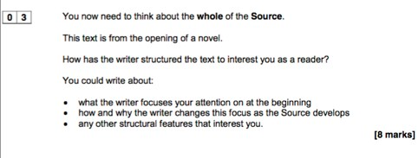

You will notice that it gives you some bullet points on which to focus, much like the previous question; don’t ignore these! You’ll also notice that it asks how the structure interests you as a reader; you have to be interested, ‘it doesn’t’ is not an acceptable answer!

Again, you don’t have to fill all of the available space but very short answers will be self-penalising as they won’t give you space to explore your points in detail.
The mark scheme for this question is below.

Analysing structure could be…

- Considering the sequence through the passage - What is revealed when?
Is it strictly chronological?
Are there any surprises?
Is there a flashback or flash-forward?
Did the event occur in the recent past, the distant past or is it still going on?
- Considering the perspectives- Does it move from big to small or ‘zoom in’?
Does it take an outside to inward perspective or vice versa?
Are there any big shifts of focus in the piece?
- Introductions and developments- What is introduced when?
What developments occur?
How are they significant?
- Reiterations- Are things repeatedly emphasised throughout?
- Repetitions, threads, patterns and motifs-
Is there something specific that appears throughout the text? Does the writer use repetition? Are there any patterns within the text?
- Narrative voice- Who is talking?
Is it first-person or third-person? Does the voice change? Why is this significant?
- Connections and links across paragraphs-
Is there a pattern? Do all of the paragraphs connect? How are the opening and closing lines/paragraphs connected?

What do the exam board say about this question?
- Students need to focus on the whole text in their response to this question.
- Responses that describe rather than analyse will attain the lowest marks on this question.
- Responses that elaborate on points with reference to the some of the effects of structure will attain middle marks.
- Top marks will be awarded to responses that link the use of structure, how it’s effective and the effect on the reader in a complex and detailed way.
A top band response-
- Shows detailed and perceptive understanding of the effects of structure
- Analyses the effects of the writer’s use of structural features
- Selects a judicious range of relevant quotations
- Uses sophisticated subject terminology accurately

Use the structural analysis guide on the previous page to help you consider what to focus on when writing this response.

1-2 Marks | A 1-2 mark response will show simple awareness of structural features. It will offer simple comment on the effect of structural features and support these with simple quotations.
 | ‘The text is written in paragraphs which makes it easy to read. It tells us about the weather first which sets the scene and then moves on to tell us about the coach.’
3-4 Marks | A 3-4 mark responses will go a little further in its attempts to comment on the effects of structural features. There will be selection of more appropriate quotes and some use of technical terms will be used.
 | The writer writes about the weather in the first paragraph which makes the reader feel they were there in the cold and rain. It then moves on to focus on some individuals so we can pick them out - the driver and then the people inside the coach, making the reader feel more comfortable but still feeling the drips of rain. So overall the writer changes the focus from outside to inside.
5-6 Marks | A response that gains 5-6 marks will be more developed and show clear understanding of structural features. It will explain clearly the effects of the writer’s use of these features. There will be a range of relevant quotes used and there will be accurate use of technical terms.
 | The main structure of the story, which begins with the weather, moves from the outside with the rain and wind that came ‘in gusts’ and which includes the driver and horses, to the inside of the coach and the individual characters who are the passengers. The reader is able to understand the extremity of the weather and then go inside to the relative calm of meet the passengers. As the extract develops it changes the focus from the weather to the driver, then the horses, then the passengers. The reader’s experience narrows down to Mary Yellan, whose thoughts take the reader back to the weather.

Below is a section of an answer that would attain 7 or 8 marks on this question.
Read through the response and annotate it, considering what the candidate does well and how they meet the success criteria.

The text, about a journey, is structured to also take the reader on a journey: from the general to the specific; from the outside to the inside; from the weather, through the coach, the driver and horses, to the passengers.

There is also a constant reminder of the weather which permeates each part - the ‘little drips of rain’ that came through the roof and, later, ‘the rain oozed through the crack in the roof’ onto Mary’s shoulder - so the reader is constantly made wet and uncomfortable, just like the passengers. Around the middle of the extract, the outside and the inside are made to coincide when the old man opens the window - this also moves the focus of the reader to the inside of the coach.

The text narrows down to take the reader from the countryside of Cornwall, the wide ‘granite sky’ and the evening which ‘closed upon the hills’, to the inside of Mary Yellan’s head as she contemplates the weather and hopes for a ‘momentary trace’ of ‘blue heaven’.

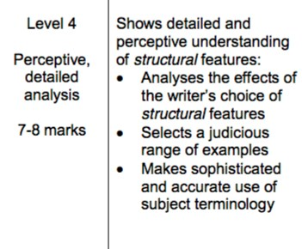

Top Tips for Question Three
- Remember to write about the whole of the source.
- Use quotes to support your answers.
- Focus on analysis of the effects of structure. Remember ‘how’ and ‘why’. Check the list above for ideas about what you could consider for this question.

How to practise Question Three:
- Complete practice papers and tasks.
- When working on and revising your Literature texts, remember that this analytical skill is also relevant for this question on this paper.
- Use the unseen resources in the accompanying resource booklet to practise close analysis of the effects of structure.

Question four carries twenty marks and is the highest tariff question in the reading section of Paper One. It is focussed on a specific section of the extract and requires you to respond to a given statement. It requires an extended response and you need to critically evaluate the writer’s use of language and structure. The question will look like this:
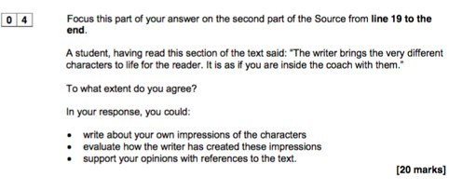

Again, there are some bullet points that help you think about what to focus on in your points. As you can see, it requires a personal response as well as engagement with the given statement and analytical comment on the extract. Whilst it will ask you to what extent you agree with a statement, it is worth noting that the statements will be ‘true’ and they are designed so that you can agree with them (although the board are clear that you don’t have to agree).

The mark scheme for this question is below:

What do the exam board say about this question?

- The question invites you to take a view; therefore, it is important that you express a personal opinion within your response.
- You should take a view on the the writer’s intended impact and therefore you need to consider the form and purpose of the extract. It would be very hard to evaluate something without considering what it set out to do!
- The exam board are clear that this question is about personal judgement that is consistently supported with references to and evidence from the text.
- As it is a critical evaluation, you shouldn’t simply narrate the piece.
- The board are very clear that you must focus your response around the statement given and they also provide bullet points to help you structure your response.
- The board state clearly that this is meant to be the most challenging question on the paper so don’t panic if you find it more difficult than the previous eight-mark questions.
- It is really important that your support your points and opinions in this response.

Marking criteria:

1-5 Marks
A 1-5 mark response will show simple, limited evaluation. It will make simple, limited comments on the effect on the reader and show limited understanding of the writer’s methods. It will select simple, limited textual references and make a simple, limited response to the focus of the statement.
‘The characters are good because you can see what they are like. The old man is funny because he opens the window and makes everybody wet. Also the writer makes us understand he us angry by saying ‘he rose from his seat in a fury.’

6-10 Marks
A 6-10 mark response will show some attempts at evaluation. It will make some evaluative comments on the edict on the reader and show some understanding of the writer’s methods. It will select some appropriate textual references and make some response to the focus of the statement.
‘The characters are good because the writer includes detail to make them seem different. The ‘old fellow’ makes us laugh because he is so angry that he is ‘fumbling’ with the diner sash and so gets everybody wet. The writer makes us understand tar he is telling us that he had kept up a constant complaint ever since he joined the coach from Truro.’

11-15 Marks
A response that gains 11-15 marks will show clear and relevant evaluation. It will evaluate clearly the effects on the reader and show clear understanding of the writer’s methods. It will select a range of relevant textual references and make a clear and relevant response to the focus of the statement.
‘The writer brings the characters alive by making them behave and react differently. The ‘old fellow’ from Truro loses his temper with the driver but makes things worse for everybody by opening the window and ‘bringing a shower of rain on himself and his fellow passengers’. This amuses the reader because the man is angry and foolish. We also understand the irony of his actions and how pointless it is curing the driver, who the reader knows is doing his best. The writer makes the man seem unreasonable and out of control by the use of excessive, almost violent words like ‘rogue’ and ‘murderer’.’

16-20 Marks
A response that attains 16-20 marks will demonstrate perceptive and detailed evaluation. It will evaluate critically and in detail the effects on the reader and show perceptive understanding of the writer’s methods. It will select a judicious range of textual detail and develop a convincing and critical response of the focus of the statement.
‘We might think that the passengers are a unified group because the writer refers to them collectively: ‘The few passengers huddled together for warmth’, but their actions suggest how different they are. The ‘old fellow’ is short tempered and pompous with a sense of how own important, but also ridiculous in his actions. The writer’s choice of the word ‘petulant’ shows how his behaviour is childish. He also makes rash statements - that he would ‘never travel by coach again’ which the reader knows is of no interest to the river he is swearing at. In the end, he is reduced to muttering. These complexities help the reader understand the stresses of the journey and the different sides to the man.’

The following response would attain fifteen to sixteen marks on this question. Read through the response and annotate it, considering what the candidate does well and how they meet the success criteria as well as how they could secure top band marks.

To a large extent, I agree wth the reader. I think because the writer had described the characteristics. The weather also helps as I feel that each character’s view as they saw the weather allows us to empathise with their feelings. For example, the fact that all the passengers ‘huddled together’ for warmth, exclaiming ‘in unison’ shows that they are all cold and frightened for they ‘huddled together’. They must all be terrified and are feeling and thinking the same. They are exclaiming ‘in unison’; the use if the word ‘exclaiming’ just shows how scared they must be, and how terrified, because of the weather. By them all being together and acting as one, I feel as if I am there too, with them.
As Mary Yellan sits in the ‘opposite corner’ from the others implies that she feels secluded and alone but she sits where rain fell through a crack in the roof. I am sympathetic towards her and feel as though I want to of and comfort here in some way. Especially because her eyes were ‘fixed’ on the window and she seemed to be hoping with desperate interest that some ray of light would ‘break the heavy blanket of sky’. The use if the descriptive phrase ‘desperate interest’ shows that she is hoping with all her might that something will happen and stop herself and the others on the coach feeling discombobulated. Normally blankets make you feel protected and warm, but in this case, she was hoping that ‘some ray of light would break the heavy blanket’. This blanket was smothering and suffocating them and she seemed a saviour, the Sun. Reading this, I think and want the same as she does. I feel as though I am on the coach, seeking protection.

Top Tips for Question Four
- Remember to write about the specified lines only.
- Use quotes to support your answers.
- Focus on the responding to the statement given and use the supporting bullet points to help you.
- Remember that this is a detailed, evaluative response.

How to practise Question Four
- Complete practice papers and tasks.
- When working on and revising your Literature texts, remember that many of the skills are transferable.

